**Estimation Method:** GotoGro-MRM

**Sprint Backlog Item – PDF Report Generator**

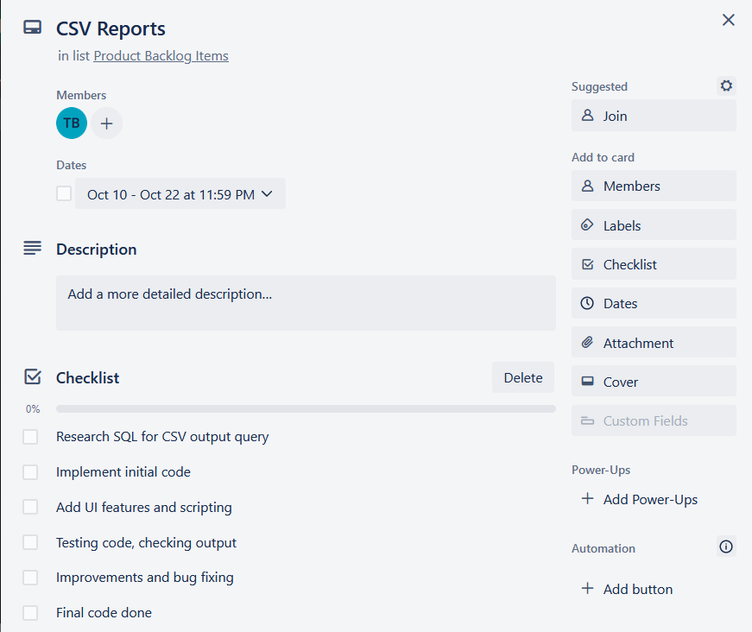The sprint backlog item selected for this prediction is the “PDF report generator”. This item can be broken down into numerous product backlog items as shown in **Figure 1**, a snapshot from the Trello task:

***Figure 1:*** *Product backlog of the CSV reporting interface.*

**Estimation Techniques**

There are multiple components involved and using a combination of analogy, size-estimation and the Delphi method, the time taken to execute each component can be estimated.

The analogy method basically looks at tasks that are similar and the time they took to complete. The more similar the chose task is to the analogous task, the more precise the time estimates are likely to be. The size-estimation follows the same trend but looks at more quantitative measures. For example, if a previous task required implementing three pages of HTML and the new task requires 2 pages, it’s fair to estimate that the new task will take less time than the previous. Finally, the Delphi method involves engaging a range of knowledgeable participants to get their opinion on how long a task is going to take.

**Actual Estimate**

Using the analogy estimation, this task does not have a high similarity with any of the prior tasks except in the UI components. The plan involves a single button to generate the report as well as two date input fields to define the start and end point. The UI task for the member input field took 1.5 hours to implement with 1 button and 4 input fields. It is therefore reasonable to assume that the UI components of this task will take approximately 1 hour.

Similarly, using a size-estimation, it is known that this report will require 3 SQL statements, one being a complex JOIN. A prior task generously assigned 20 minutes to each SQL statement, meaning this task would also take approximately 1 hour. It is reasonable to add a buffer of half an hour to allow for the additional complexity of the JOIN statement.

Though the triggering code in the button is the same, the code for reading the results of the SQL statement and printing them to the report does not have a comparable task to draw either an analogy or size comparison. For this, we used the Delphi method throughout the group and took their opinions of how long they think the task should take. Across the 5 team members the time opinions were: 1, 2, 2, 1.5, 3, 1.5. The mean of these estimates being 1.8 hours. Adding a slight buffer to estimation (as is best practice), the Delphi method yields that coding the PDF output script should take around 2 hours.

In total, the entire item is estimated to take **4 hours** to complete, not including bug fixing and testing.